BSCS FINAL PROJECT

<Phase>

<Project Title>



Project Advisor

**<Advisor Name>**

Presented by:

**Group ID: xxxxxxx**

Student Reg# Student Name

**Faculty of Information Technology**

**University of Central Punjab**

Software Requirements Specification

Version <Version #>

<Project Name>

Advisor: <Advisor Name>

Group <Group ID>

|  |  |
| --- | --- |
| Member Name | Primary Responsibility |
|  |  |
|  |  |
|  |  |
|  |  |

Table of Contents

Table of Contents iii

Revision History iv

1. Introduction 1

1.1 Review of Related Literature 1

1.2 Problem Statement 1

1.3 Proposed Solution 1

1.4 Problem Scope 1

1.5 Challenges 1

1.6 Knowledge Areas Required 1

1.7 Completeness Criteria 1

1.8 Research Outcomes/Nature of End Product 1

1.9 Learning Outcomes 1

1.10 Document Conventions 1

2. Background Study and Literature Survey 2

3. Overall Description 2

3.1 Proposed Solution 2

3.2 User Classes and Characteristics (if applicable) 2

3.3 Operating Environment 2

3.4 Design and Implementation Constraints 2

3.5 Assumptions and Dependencies 2

4. Functional Requirements 3

4.1 Requirement 1 OR Use-Case 1 (if requirements are modeled as use cases) 3

4.2 Requirement 2 OR Use-Case 2 (and so on) 3

4.3 Proposed Workflow 4

4.4 Analysis and Modeling of Requirements 4

5. Nonfunctional Requirements 4

5.1 Target Performance 4

5.2 Safety Requirements (if applicable) 4

5.3 Security Requirements (if applicable) 4

5.4 Additional Software Quality Attributes 4

6. Other Requirements 4

7. Initial Results 5

8. Revised Project Plan 5

9. References 5

Appendix A: Glossary 6

Appendix B: IV & V Report 7

(Independent verification & validation) 7

Revision History

|  |  |  |  |
| --- | --- | --- | --- |
| **Name** | **Date** | **Reason For Changes** | **Version** |
|  |  |  |  |
|  |  |  |  |

# Introduction

## Review of Related Literature

<Provide detailed review of related literature.>

## Problem Statement

< Describe the problem for which the solutions would be provided.>

## Proposed Solution

< Describe the proposed solution of the stated problem.>

## Problem Scope

< Describe the scope of the problem that is covered by this SRS >

## Challenges

## Knowledge Areas Required

## Completeness Criteria

## Research Outcomes/Nature of End Product

## Learning Outcomes

## Document Conventions

<Describe any standards or typographical conventions that were followed when writing this SRS, such as fonts or highlighting that have special significance. For example, state whether italicized nouns represent external systems.>

# Background Study and Literature Survey

*<Provide understanding of the problem domain and detailed review of literature. Also provide limitations of existing work. Make headings as per requirement.>*

# Overall Description

## Proposed Solution

Input image

Scattering image

Object detections

Remove useless objects

Comparing with Dataset

no

Ignored image

Save person on dataset

Show result

The body parts of the performer are detected using sensors so that the application compares the real-time body position with the correct data set stored in the applications. After comparing the real time info with stored data set, application will predict the correct position needed for the exercise.

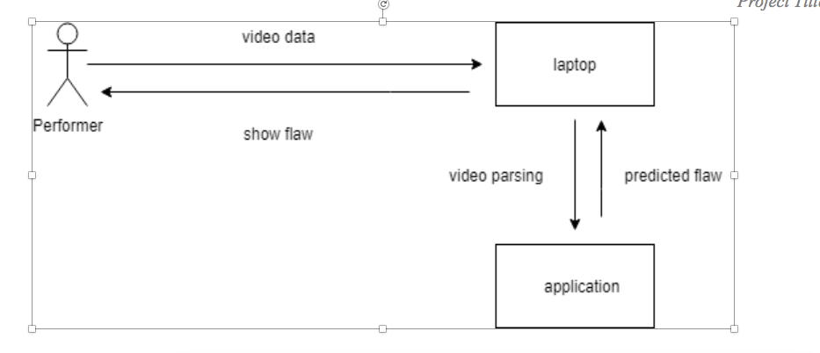

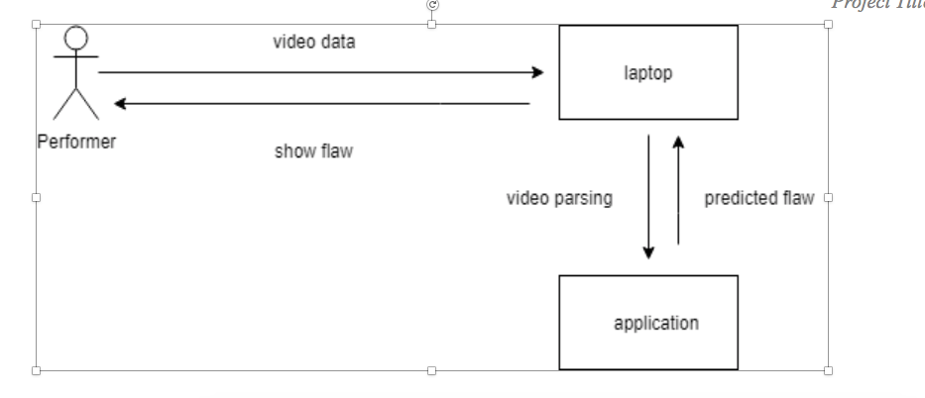

## User Classes and Characteristics (if applicable)

User classes are based on Dataset and Dataset will be different according to the age, gender so that,

* Male person Dataset
* Female person Dataset

## Operating Environment

* *This system will be used in flat surface room*
* *Must have high processor Laptop*
* *Must have Webcam*
* *Must install Virtual gym trainer app on laptop*

## Design and Implementation Constraints

We want to do this by using Xbox Kinect or   Arduino sensors

Advantages:

* These devices give high accurate data
* Give result in less processing time

Dish advantages:

* Expensive
* Limited scope
* Complex installation

**Therefore,** we cannot use these devices that is because of low accuracy rate of image processing . In situations it produces junk values or inaccurate reading

## Assumptions and Dependencies

* We assume that our system will be placed in the room and room will be flat .
* Background of the workout person will be fix not any movable thing behind the workout person
* Person must be front of webcam.

The assumed factors that could affected the requirements are because of

* Its accuracy depends upon the reading of image processing
* any movable thing behind the workout person can be affected our assumptions

Functional Requirements

<Functional requirements can be expressed as use-cases. Fill out the following template for each use-case if the requirements are modeled as use-cases. Otherwise write requirements one by one under each heading. Number every requirement. If modeling as use cases, do not name a use case as “Use-Case 1.” State the use-case name like “Withdraw Cash from ATM”. A use-case may have multiple alternate courses of action. >

<Provide a Use Case Diagram before describing the use cases.>

## Requirement 1 OR Use-Case 1 (if requirements are modeled as use cases)

|  |  |  |  |
| --- | --- | --- | --- |
| **Identifier** | | UC-1 | |
| **Purpose** | | … | |
| **Priority** | | <Choose one from {High, Medium, Low}> | |
| **Pre-conditions** | | … | |
| **Post-conditions** | | … | |
| **Typical Course of Action** | | | |
| **S#** | **Actor Action** | | **System Response** |
| **1** |  | |  |
| **2** |  | |  |
| **3** |  | |  |
| **…** |  | |  |
| **Alternate Course of Action** | | | |
| **S#** | **Actor Action** | | **System Response** |
| **1** |  | |  |
| **2** |  | |  |
| **3** |  | |  |
| **…** |  | |  |

Table 1: UC-1

## Requirement 2 OR Use-Case 2 (and so on)

*<For example a requirement can be written as follows:*

1. *The proposed system should be able to perform tasks….>*

## Proposed Workflow

## Analysis and Modeling of Requirements

<If applicable Include the following analysis models: use-case diagram (provide before Section 4.1), entity-relationship diagram, abstract class diagram, sequence diagram (to model system inputs and outputs, interaction between system and external world). Additional diagrams may be added for example flow chart, state diagram, data flow diagram (to model system inputs and outputs, interaction between system and external world), decision table, event table etc.>

# Nonfunctional Requirements

## Target Performance

<Provide target accuracy and efficiency etc. Other performance parameters may also be used. Describe those parameters and target values of those parameters.>

## Safety Requirements (if applicable)

<Specify those requirements that are concerned with possible loss, damage, or harm that could result from the use of the product. Define any safeguards or actions that must be taken, as well as actions that must be prevented. Refer to any external policies or regulations that state safety issues that affect the product’s design or use. Define any safety certifications that must be satisfied.>

## Security Requirements (if applicable)

<Specify any requirements regarding security or privacy issues surrounding use of the product or protection of the data used or created by the product. Define any user identity authentication requirements. Refer to any external policies or regulations containing security issues that affect the product. Define any security or privacy certifications that must be satisfied.>

## Additional Software Quality Attributes

<Specify any additional quality characteristics for the product that will be important to either the customers or the developers. Some to consider are: adaptability, availability, correctness, flexibility, interoperability, maintainability, portability, reliability, reusability, robustness, testability, and usability. Write these to be specific, quantitative, and verifiable when possible. At the least, clarify the relative preferences for various attributes, such as ease of use over ease of learning.>

# Other Requirements

<Define any other requirements not covered elsewhere in the SRS. These might include database requirements, external (hardware, software, or communication) interface requirements, internationalization requirements, legal requirements, and reuse objectives for the project.>

# Initial Results

*<Provide initial results obtained so far>*

# Revised Project Plan

<Provide project progress in accordance with the plan provided in project proposal. Gantt chart should be used in this regard. Use Microsoft Office to develop the Gantt chart. Also provide an updated project plan.>

# References

<List all books, conference papers, journal articles, websites, etc. used in preparing the content of this SRS. Provide enough information so that the reader could access a copy of each reference, including title, author, volume/edition number, page number(s), and publication year. Mention complete URLs for websites.>

Appendix A: Glossary

<Define all the terms necessary to properly interpret the SRS, including acronyms and abbreviations. You may wish to build a separate glossary that spans multiple projects or the entire organization, and just include terms specific to a single project in each SRS.>

Appendix B: IV & V Report

(Independent verification & validation)

**IV & V Resource**

Name Signature

|  |  |  |  |  |  |
| --- | --- | --- | --- | --- | --- |
| **S#** | **Defect Description** | **Origin Stage** | **Status** | **Fix Time** | |
| **Hours** | **Minutes** |
| 1 |  |  |  |  |  |
| 2 |  |  |  |  |  |
| 3 |  |  |  |  |  |
| … |  |  |  |  |  |

**Table 3: List of non-trivial defects**